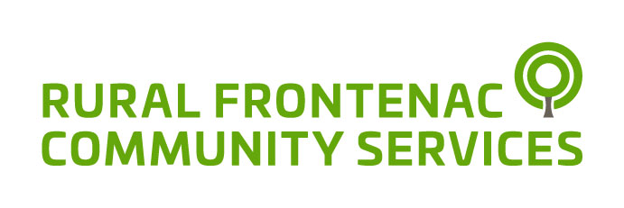

Celebrating 45 Years of Serving the Community.

Since 1975 Rural Frontenac Community Services has embraced the meaning of community with a team of compassionate and dedicated individuals connecting people of all ages.

We provide a wide range of services enabling residents to live rural life to its fullest.

Annual Report
2019/2020

Our Mission
To provide opportunities that will enhance the well-being and self-sufficiency of all community members.

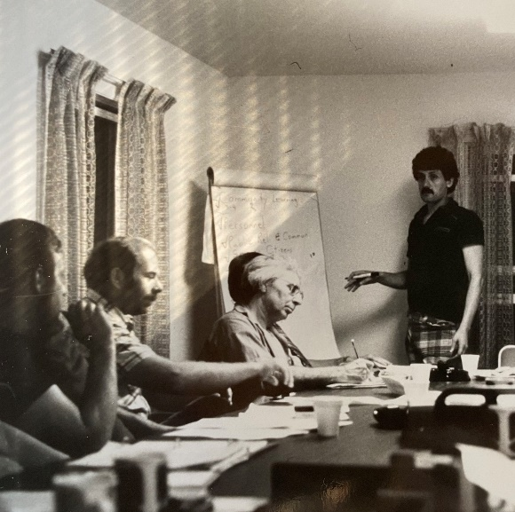
Annual Update

We are stronger together!

Rural Frontenac Community Services is the glue that holds us, volunteers and staff, together so that we can be strong for those with no voice. We provide employment in the community for those who are qualified and outlets for those who do not require a job but who want to contribute to the safety, security and prosperity of our community by volunteering.
The Covid-19 pandemic has given us a view of what a worst case scenario might look like. We are happy to report that with excellent stewardship and great leaders we have managed well. It is important to be fiscally responsible, and to hire strong and skilled leaders. These are the people who will instill confidence no matter what unknown challenges the future might hold. We can only hope that the leaders of the future can emulate our present team.
We want to thank our dedicated and committed staff who have served Rural Frontenac Community Services for the last year. Through the changes, uncertainty and concerns about their own health, they have remained committed to the community ensuring our most vulnerable citizens are cared for. Lastly, it is important to reflect on the Rural Frontenac Community Services Board of Directors, who as individuals from the community have volunteered their time, some for decades, to preserve the rural way of life in Frontenac.
We thank you all.
Steve Magee, Chair
Louise Moody, Executive Director
Meals-on-Wheels Celebrating 20 years

2019/20 HIGHLIGHTS
Mike Procter, our Adult Protective Services Worker for 34 years, retired in December 2019. Mike was our Jack of all Trades, our Master of Ceremonies, our Stand-Up Comedian, our Mouse Catcher, our Pie Auctioneer, resident Handyperson, and Emergency Receptionist….he is missed.

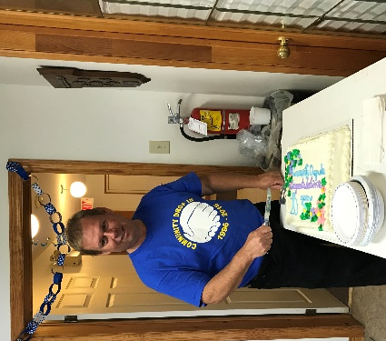
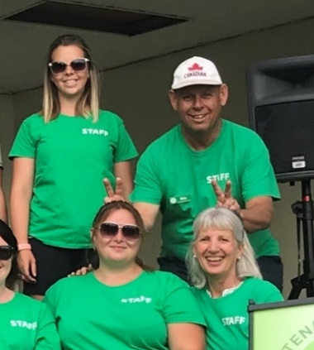
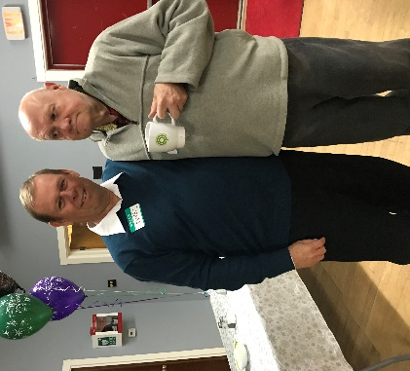

Community Support Services (CSS) providing care at home to seniors.
Last year Community Support Services served 394 seniors. We provided 2,932 hours to assist clients maintain their homes and 3,111 hours of respite with our dedicated PSW staff team. In response to the pandemic, our CSS team has stepped up. The Meals-on-Wheels kitchen has prepared and delivered nearly as many meals in 5 months as we did all of last year.
EarlyON drop-in programs for parents and caregivers with children birth to 6 years of age
Our EarlyON Program operates in nine different locations throughout Frontenac County, including Arden, Depot Lakes Conservation Area, Harrowsmith, Mountain Grove, Plevna, Sharbot Lake, Storrington, Sydenham and Verona. Over the last year we served 356 children and 208 adults at our 18 weekly groups.
Frontenac Transportation Services (FTS) providing volunteer transportation.

In 2019, FTS provided 9,344 one-way rides to 254 residents. Our volunteers drove 550,000 kms. donating over 13,000 volunteer hours. During the pandemic volunteer drivers have also been delivering Meals-on-Wheels, groceries, medicine and takeout orders from local businesses.
Rural Frontenac Youth Hub opened in 2019
On October 10, 2019, the Rural Frontenac Youth Hub opened for bi-weekly drop in for youth in grades 9 to 12 to hang out, gain access to services and have a nutritional snack. Fifteen youth were served between October and the closure in March due to Covid-19. The hub moved to a virtual platform connecting with youth through Zoom. In 2019 our Youth Program served 25 youth ages 14-24 living in Frontenac County to gain access to various services including mental health, housing, and food security. Out of these youth 5 were identified as living rough and were given support to find stable and secure housing.
Family Counselling
Our Family Counsellor provided 354 counselling sessions to 64 clients, providing 417 hours of service.
Kids Club Youth Program
Kids Club was offered at 5 locations in Frontenac County once a week. Seventy-eight youth registered from grades 2-8. We offered nutritional snacks, leadership opportunities, crafts, and games. The program ended on March 16th, 2020 due to the Covid-19 outbreak.

OUR DAYCARE TURNS 30
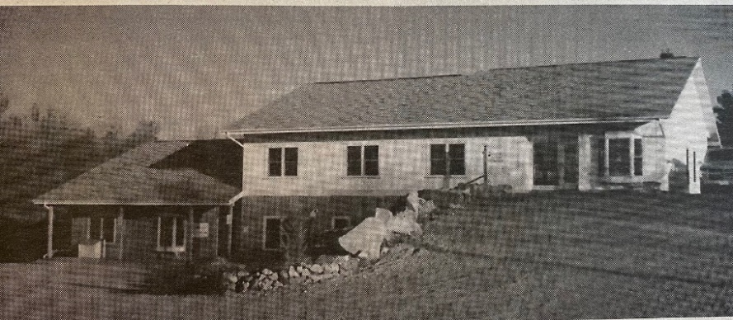

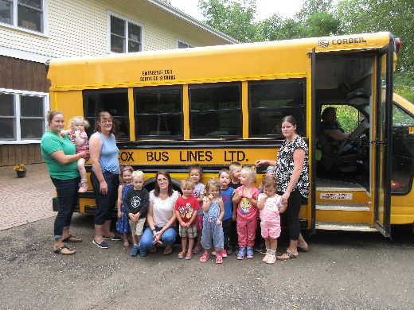
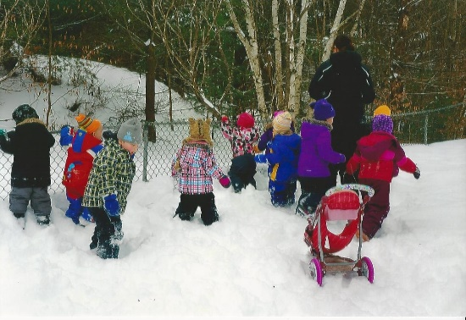
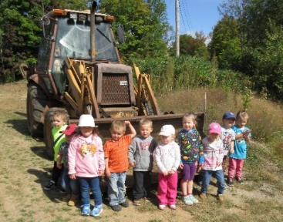
On Feb 18, 1991 Susan Wilby opened the licensed daycare with eight children. Over the years, we have cared for 784 children and their 487 families.
Thirty years later, our daycare remains a model to celebrate. We provide a professional caring “little rural daycare” embracing How Does Learning Happen? in all our activities. Susan Wilby remains the dedicated professional she was when we hired her nearly 30 years ago. There have been many changes over the years. Staff have come and gone, children grow up and the regulations are always changing. The one thing that hasn’t changed over the years is the ‘FAMILY’ atmosphere that our Daycare and building offers. We have a beautiful yard and bright playrooms for the children.

OUR PEOPLE
Administration  Louise Moody  Joyce Lewis  Nicki Gowdy  Rhonda Watkins  Bill Kennedy  Seniors Support  Vicki Butler  Jasmine Dopking  Anne Howes  Karin Reynolds  Leigh Russell  Sandra Thiel  Catherine Tysick (Manager)  Laura Wood  Community Services  Branden Leach  Mike Procter | EarlyON  Marcie Asselstine  Maggie Asselstine  Alison Caird  Penny Cota  Brittany Cowdy  Melissa Elliott (Supervisor)  Jan MacPherson  Alex Revell  Alisha Spencer  Wendy Taylor  Shania Watson  Daycare  Jennifer Andrews  Lisa Hamilton  Marjory Hanna  Sarah Hueston  Deanna Lind  Marcy Paradis  Patsy Quinn  Susan Wilby (Supervisor) | Youth Services  Deanna Lind  Sarah McCullough (Coordinator)  Transportation  Nicki Gowdy  Gail Young (Administrator)  Board Members  Linda Chappel (Past Chair)  Keith Conboy (Secretary)  Mary Jo Dowker  Ken Fisher  Danika Gill  Susan Irwin (Vice-Chair)  Amrit Kaillon  Steve Magee (Chair)  John Purdon ( Treasurer)  Kathi Zarfas
Figure 1Sarah McCullough joned our youth team this year.
Figure 2Sarah McCullough joined our youth team this year
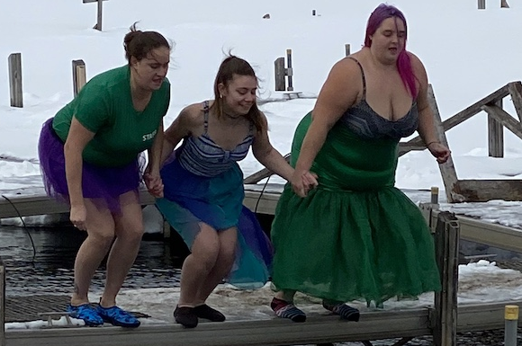

In March, we welcomed Karla Dibdin, Supervisor, to our EarlyON team.
Our Youth staff taking the Polar Plunge for the team!

financials
Treasurer’s Report

The most usual annual constant is change. 2019-2020 was not different.
Much of our accounting in the recent past has been outsourced to a third party not for profit but they opted out of the agreement. The Board agreed to assume all accounting services internally with staff and support from a consultant. The usual learning challenges when transitioning to new tasks were conquered and operations are now smooth and efficient.
Our long time treasurer, Bob Webster, did not seek re-election to the Board and so a new treasurer had to be appointed. We thank Bob for his service and the benefit of his professional accounting expertise.
Covid-19 appeared earlier this year causing some disruptions to operations and services in March, the last month of our fiscal year, but as we all know the pandemic challenges have continued into the current fiscal year with no end in sight.
The challenges were met and operating results continue to be strong with a cash surplus of $80,263 compared to the 2018-2019 surplus of $37,251. The net surplus generated was $51,909 compared to $11,093 in the preceding year.
The financial position of the organization remained strong with cash and short-term investments at year end in the amount of $410,144 compared to $472,870 on March 31 2019. Maintaining a strong cash position is essential to ensure the portfolio of services can continue to be offered throughout Rural Frontenac.
Thanks to our funders, our staff and our volunteers, Rural Frontenac Community Services can continue to provide services to our communities.

John Purdon
Treasurer

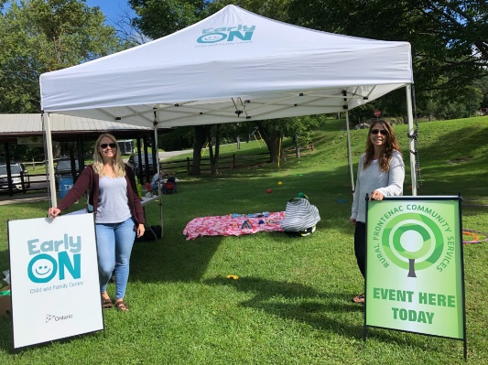
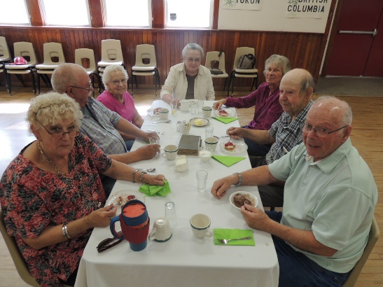
* Outreach programming offered in Arden, Storrington, Ompah, Parham, Harrowsmith, Mountain Grove, Plevna, Snow Road and Verona.

City of Kingston – Consolidated Municipal Manager
Community Foundation for Kingston and Area
County of Frontenac
Ontario Ministry of Health
Ontario Ministry of Children, Community and Social Services
Township of North Frontenac
Township of Central Frontenac
Township of South Frontenac
United Way - Kingston, Frontenac, Lennox & Addington
Donations and fundraising
* Special mention to the Gananoque Kinsmen Club TV Bingo for their generous donation of $4,000

Our Locations

Source of Funds
Adult Centre  1020 Elizabeth St.  Sharbot Lake, ON | Child Centre  1004 Art Duffy Rd.  Sharbot Lake, ON | The Centre/Youth Hub  1042 Elizabeth St.  Sharbot Lake, ON
Sydenham EarlyON
4365 Mill St,
Sydenham

Rural Frontenac Community Services

