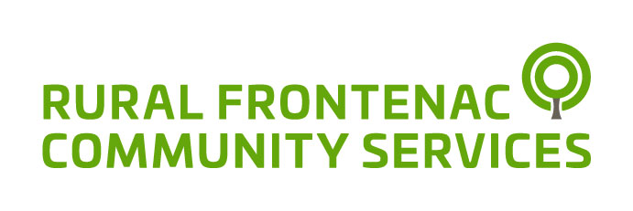

Since 1975 Rural Frontenac Community Services has embraced the meaning of community with a team of compassionate and dedicated individuals connecting people of all ages.

We provide a wide range of services enabling residents to live rural life to its fullest.

Annual Report
2018/2019

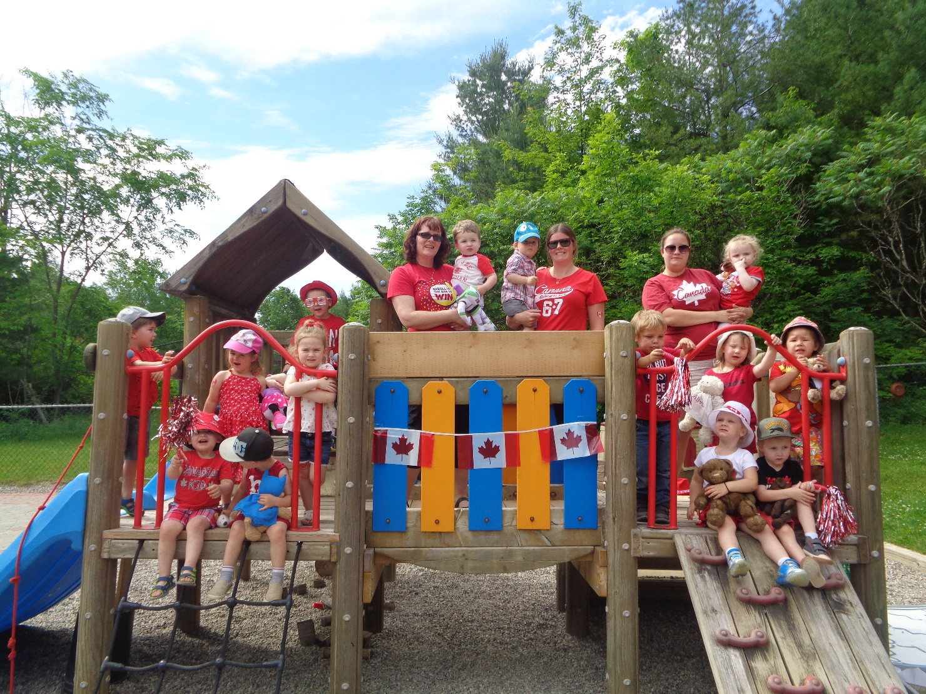

Our Mission
To provide opportunities that will enhance the well-being and self-sufficiency of all community members.

Annual Update
Over the last year the Board of Directors consulted with the community and staff to set strategic priorities for the next five years. An energetic community event was held in May with over 60 community members. The community shared stories about how Rural Frontenac Community Services had touched their lives and made an impact. Core values were articulated and the strategic priorities were reviewed and approved by the Board of Directors. This refreshed vision and priorities will anchor our future direction as we prepare to face uncertain times in the changing political landscape.
In the spring the Provincial Government announced the formation of Ontario Health Teams (OHT) to replace the Local Health Integration Networks (LHIN). OHTs are being introduced to provide a new way of organizing and delivering healthcare in Ontario. Under Ontario Health Teams, health care providers (including hospitals, doctors and home and community care providers) will work as one coordinated team with the common goal of improving health outcomes and patient/client experience. This new model will impact our Community Support Services (CSS) programs. The realignment of the seven core services offered by our CSS staff team this last year has positioned us well for this transition. Our funding for the seven core services has been reallocated to ensure we have the resources we need to support seniors and adults with disabilities remain in their homes. Throughout this transition, Rural Frontenac Community Services will continue to participate and contribute in the development of our local Ontario Health Team.
Our programming for children, youth and their families has flourished this year. Our Daycare is a vital resource to many working families. Our rural model provides flexibility for working families requiring full and part time care. Licensed for up to 24 children, our Daycare has been operating at capacity over the last year, serving thirty-one families. We also provide Enhanced Support to children who require additional supports a partnership with Community Living Kingston Preschool Service. In our annual survey, one parent told us, “The Child Centre is the best day care, our small community is so lucky to have it! All the staff make us feel like our child is their favourite.” With the expansion of EarlyON throughout Frontenac County we have been able to hire new staff, expand hours and open additional EarlyON locations. This fall we opened a new outdoor program at Depot Lake campground. We are grateful to the City of Kingston for all their support, allowing us to offer safe, affordable, and quality licensed childcare and EarlyON in our small rural communities.
With the support of United Way of KFLA, our youth program has expanded to support older youth in our community. In addition to working with youth who are at risk of homelessness we have developed a local youth advisory to open a youth HUB in Sharbot Lake. After conducting two surveys with local youth, the group opened the HUB for bi-weekly drop in. They have applied for funding to support program costs and to provide an honorarium for the youth volunteers.
The staff at Rural Frontenac Community Services are the heart and soul of the organization. We are grateful for their compassion, their creativity and their commitment. We especially want to thank and congratulate Mike Procter for his 34 years of service. Mike will be retiring this December. He will be missed.

Linda Chappel, Chair
Louise Moody, Executive Director

EarlyON’s First Anniversary

8,933
Visits

Adults

Children

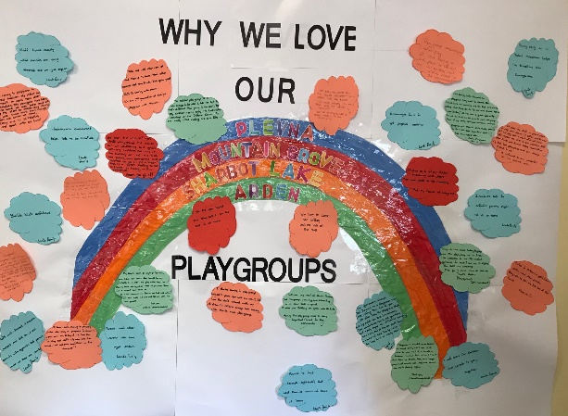
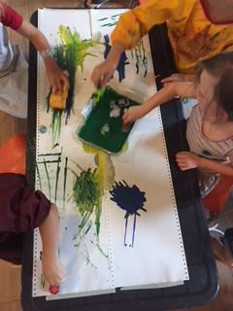

787 Programs offered
Total Programs offered at EarlyON

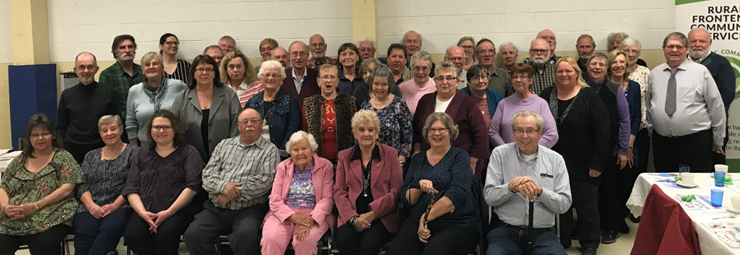
2019 highlights
Our Volunteers and their guests enjoyed our Annual Volunteer Appreciation Dinner
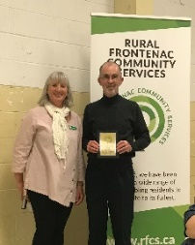
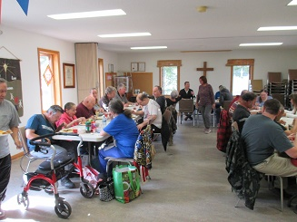
Volunteer of the Year Bob Webster
Community Drop In Celebrating 23rd Anniversary!
Community Support Services
Provided 5,714 hours of Home Help and 6,780 hours of In-Home Respite to help seniors remain in their own homes.
Frontenac Transportation Services

A vital service in Frontenac County, providing volunteer rides to residents without their own transportation, ensuring no one is left behind.

This year we provided 5,296 rides with 31 volunteer drivers who drove 610,579 kms donating 16,357 volunteer hours.

our people
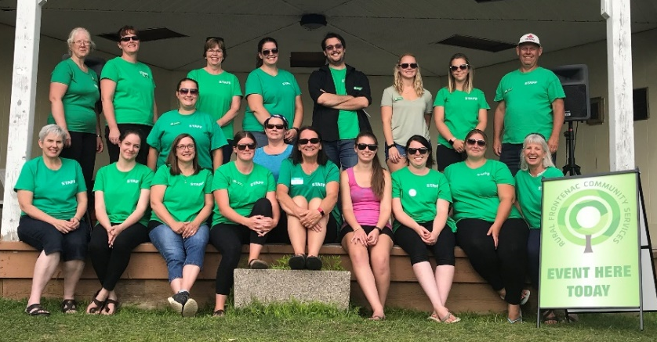
Administration  Louise Moody  Joyce Lewis  Seniors Support  Vicki Butler  Jasmine Dopking  Anne Howes  Karin Reynolds  Leigh Russell  Colleen Ryder  Sandra Thiel  Catherine Tysick (Manager)  Laura Wood  Community Services  Branden Leach  Mike Procter  Transportation  Nicki Gowdy  Gail Young (Administrator) | EarlyON  Marcie Asselstine  Maggie Asselstine  Alison Caird  Penny Cota  Brittany Cowdy  Melissa Elliott (Supervisor)  Jan MacPherson  Alex Revell  Alisha Spencer  Wendy Taylor  Shania Watson  Daycare  Jennifer Andrews  Lisa Hamilton  Marjory Hannah  Sarah Hueston  Deanna Lind  Courtney Meeks  Marcy Paradis  Patsy Quinn  Susan Wilby (Supervisor) | Youth Services  Deanna Lind  Sarah McCullough (Coordinator)  Board Members  Linda Chappel (Chair)  Keith Conboy (Secretary)  Ken Fisher  Susan Irwin  Steve Magee (Vice-Chair)  John Purdon  Bob Webster (Treasurer)  Kathi Zarfas
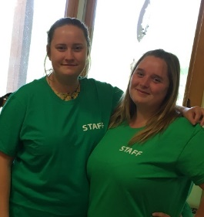
Welcome New Staff!
Figure 1Sarah McCullough joned our youth team this year.
Figure 2Sarah McCullough joined our youth team this year

financials
Treasurer’s Report

The 2018/19 fiscal year was a period of considerable change and accomplishment for Rural Frontenac Community Services.

During the year the agency launched the EarlyON children’s services platform, which more or less doubled the geographic area of coverage, as well as increasing staffing levels and hours of services delivered each week. These changes effectively doubled the amount of services provided to children and to their parents throughout rural Frontenac County. The statistics available elsewhere in this annual report reflect the great success of the launch.

The agency also successfully adapted to the introduction by the South East Local Health Integration Network of a new “basket” of services for seniors and other residents. With the new service model came substantial changes to the funding model as well. This became fully active on April 1, 2019.

Amidst these changes, operating results continued to be strong with a cash surplus generated of $37,251 representing a modest improvement over the prior year’s surplus of $34,991. Similarly, the agency generated a net surplus of $11,093 compared to $8,832 in the prior year.

The financial position of the agency remained strong with cash and investments at year end amounting to $472,870 compared to $453,398 at March 31, 2018. This has been an area of focus for the Board and management for several years. By comparison, the cash balance at March 31, 2012 was $104,980. Maintaining a strong cash position is essential to ensure that the agency’s broad portfolio of services can continue to be offered throughout the large region we serve.

I would once again like to express our sincere gratitude to our funders, our staff and our volunteers. Each of those groups is absolutely essential in order that the agency can provide the broad and comprehensive services we offer to our communities.
Bob Webster, CMA
Treasurer

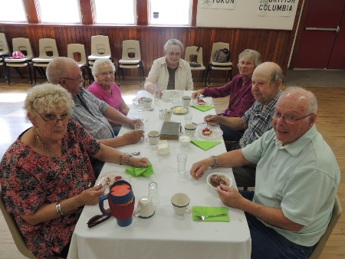
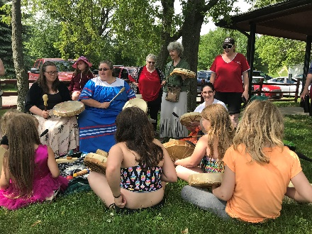

Rural Frontenac Community Services

Our Locations

Our Funders
1020 Elizabeth St.  Sharbot Lake, ON  K0H 2P0 | 1004 Art Duffy Rd.  Sharbot Lake, ON  K0H 2P0 | Sydenham EarlyON  4365 Mill St,  Sydenham

City of Kingston
Community Foundation for Kingston and Area
County of Frontenac
Ontario Ministry of Health
Ontario Ministry of Children, Community and Social Services
Township of North Frontenac
Township of Central Frontenac
Township of South Frontenac
United Way - Kingston, Frontenac, Lennox & Addington

